Observation 1:

In the advertiser profile page, after clicking on edit button when we get navigated back to ‘about me’ page there the previously uploaded profile pic is not showing, rest all the previously filled details are visible as expected except for the profile photo.

Advertiser profile page:

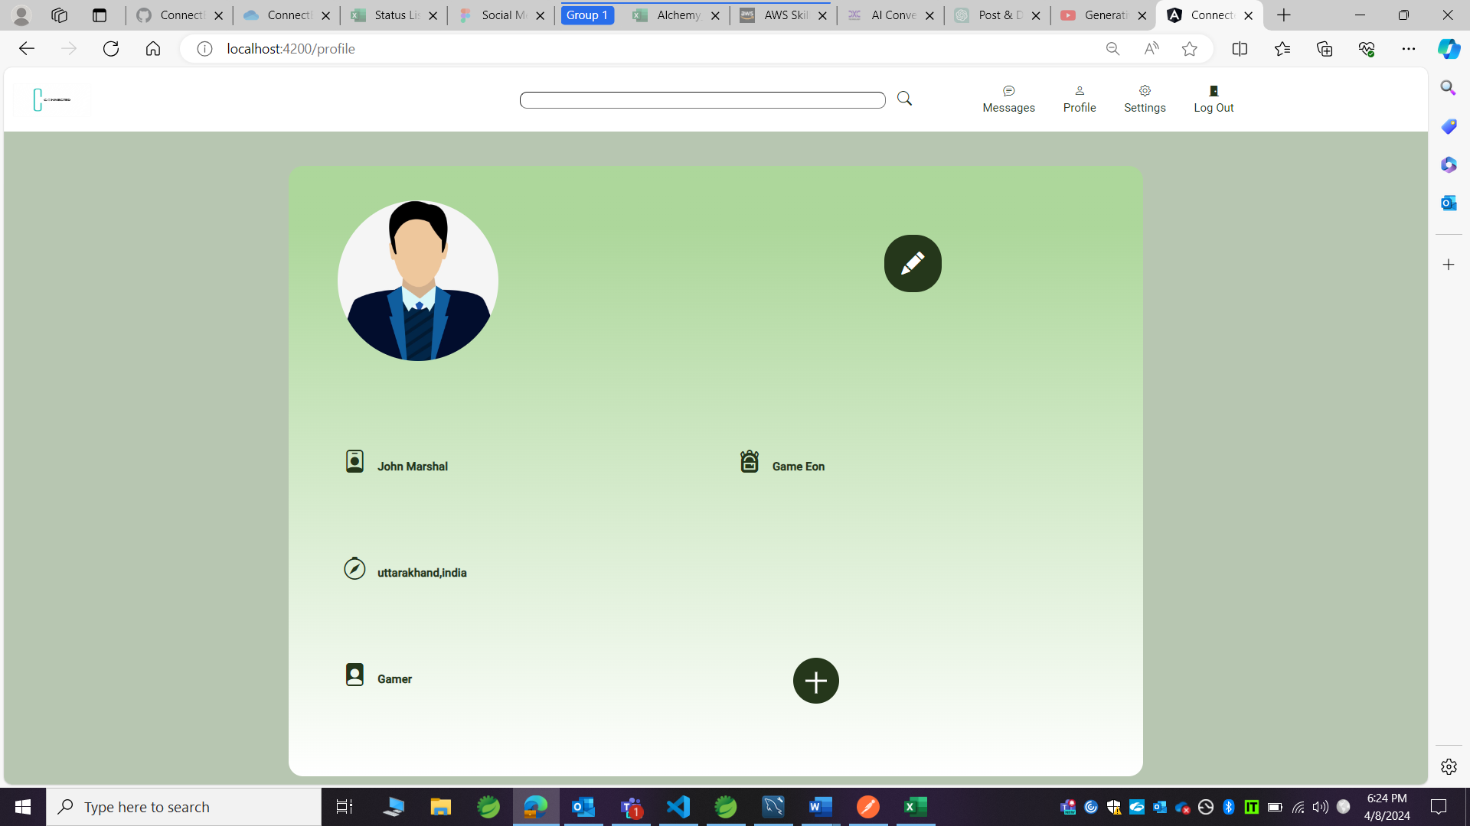

After clicking on edit button -- refer the below ss

Advertiser about me page:

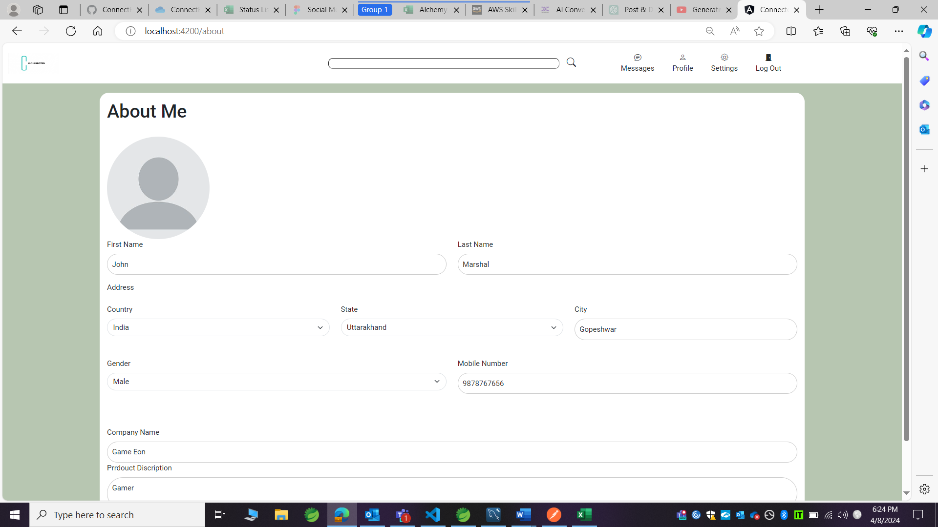

Observation 2:

After logging off If any user is logged in once again then after clicking on submit button in the login page its navigated to the next page but no details are displaying.

Advertiser profile page:

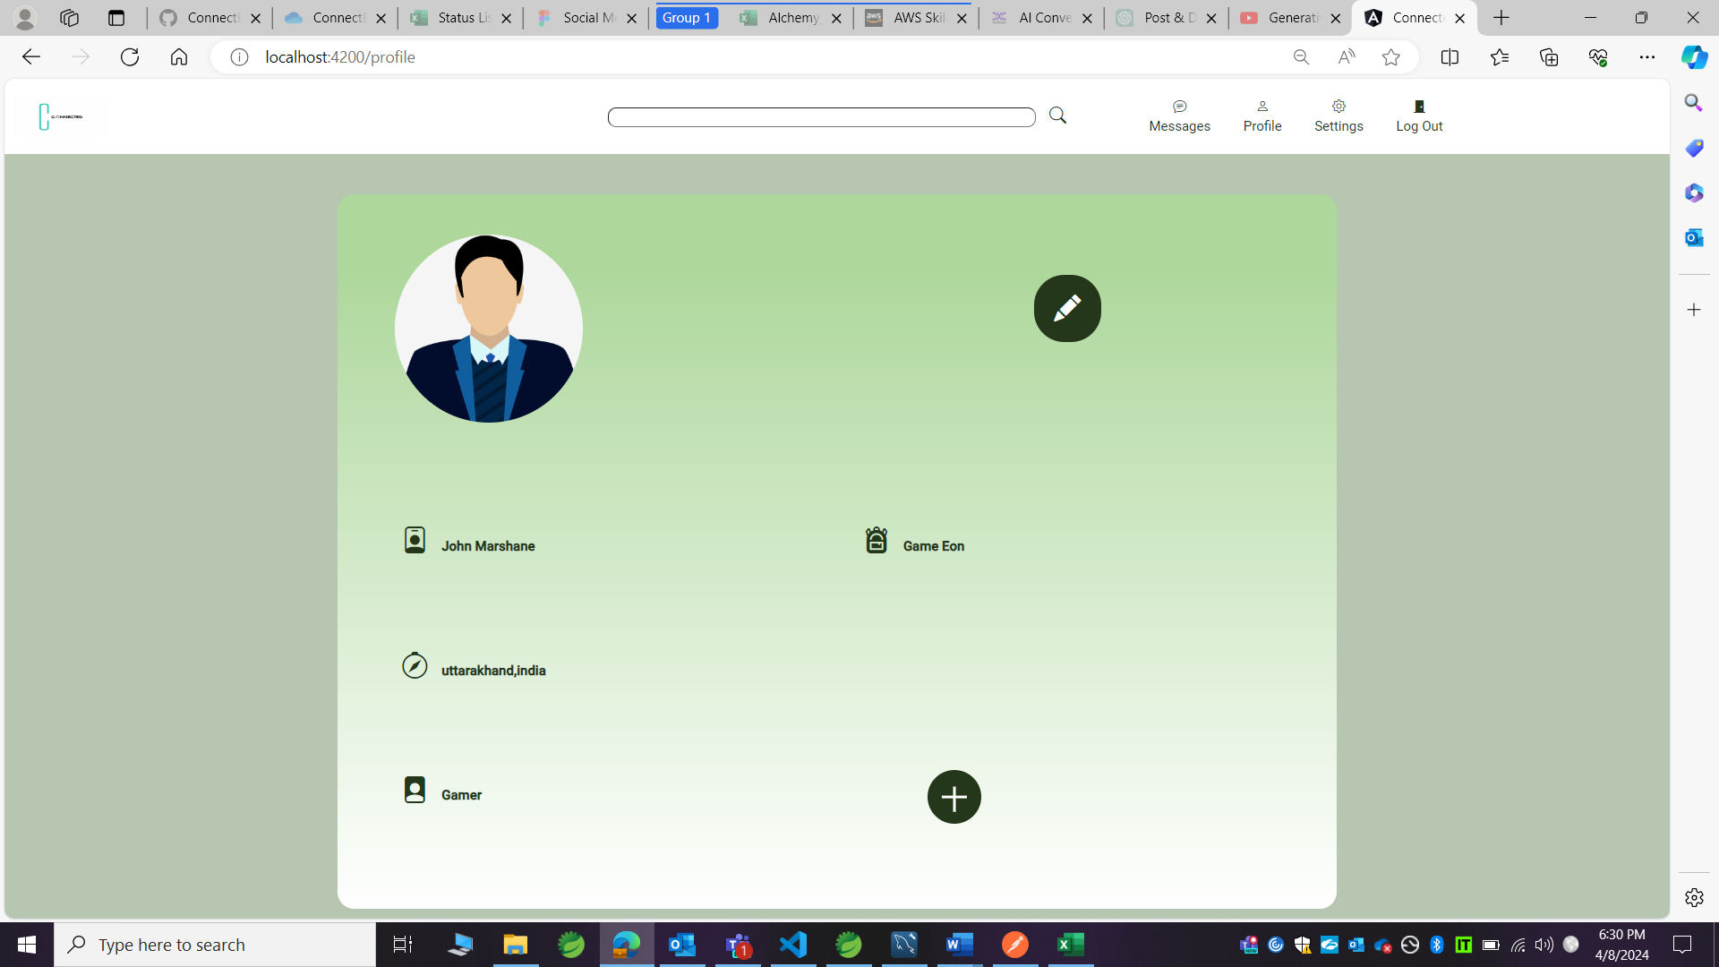

After logging off:

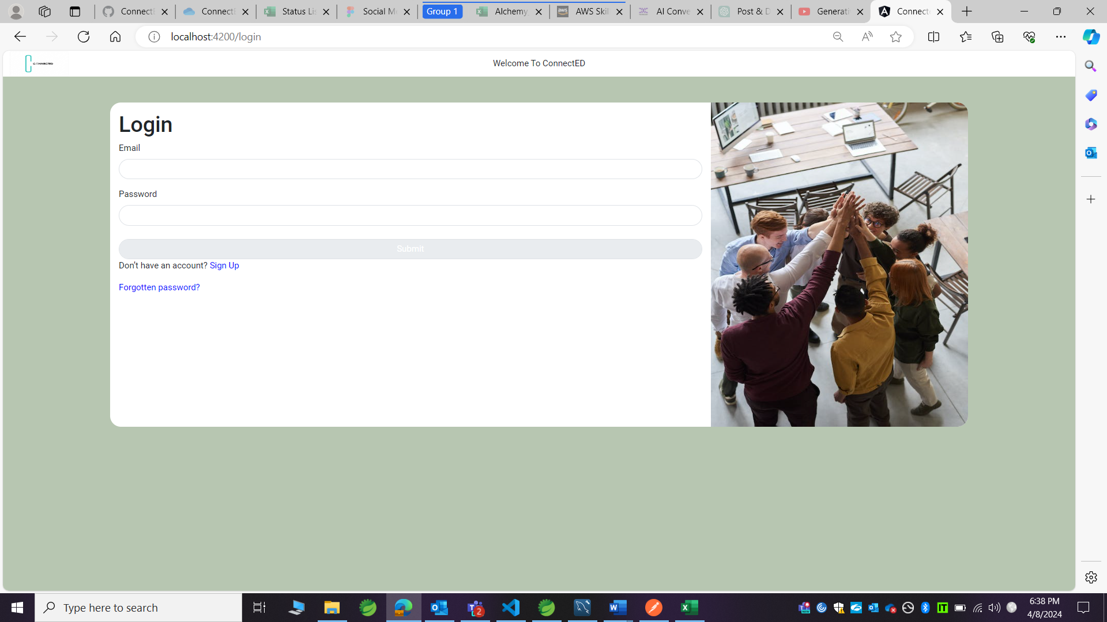

Logging in:

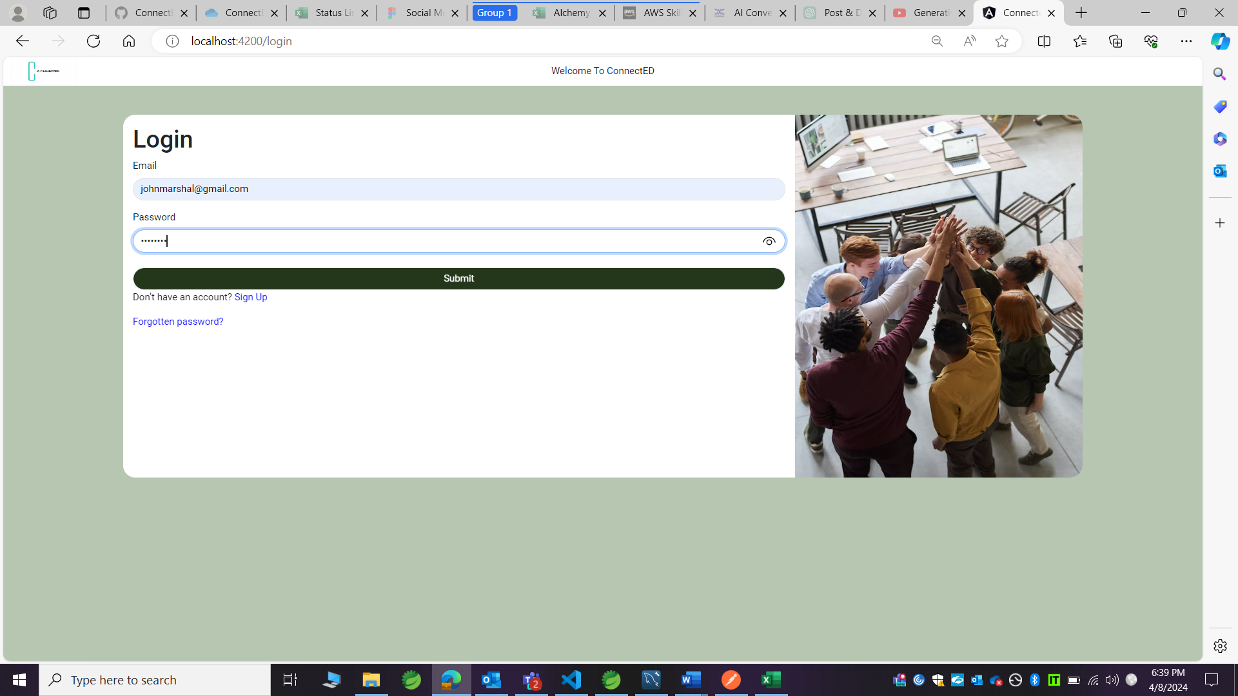

Advertiser profile page:

